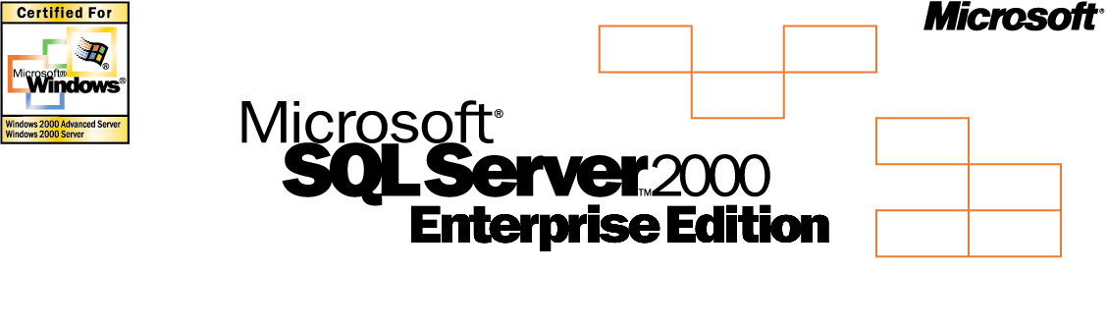

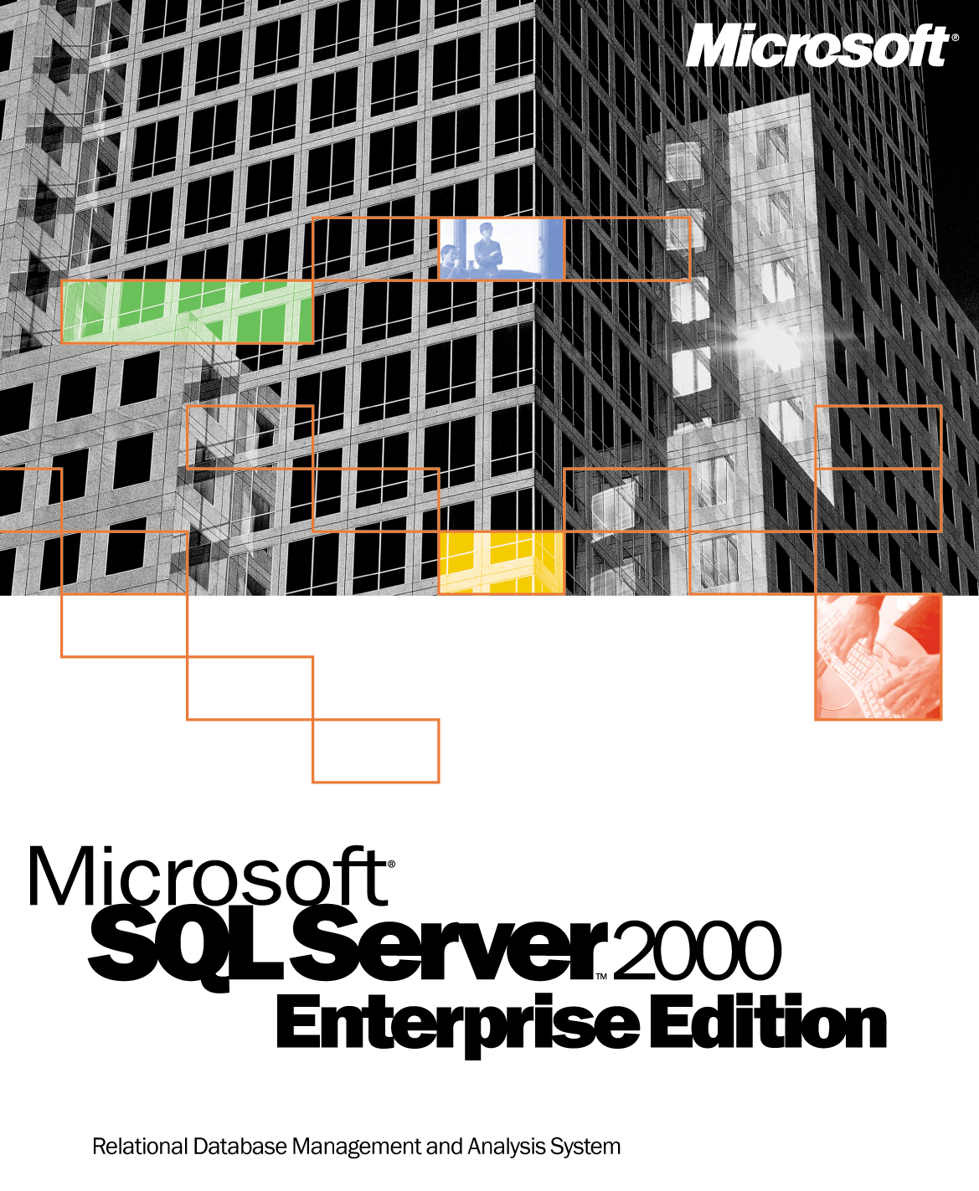

Product Highlights
Microsoft SQL Server 2000 Enterprise Edition offers a complete database and analysis platform for next-generation e-commerce,
line-of-business, and data warehousing applications. SQL Server 2000 dramatically reduces the time required to bring applications to market while offering advanced scalability and reliability for the most demanding enterprise environments.
www.microsoft.com/sql
A comprehensive database and analysis solution, SQL Server 2000 delivers the performance, scalabil-
ity, and reliability that demanding Web and enterprise line-of-business environments require. New XML and HTTP support simplify data access and inter-
change, while powerful analysis capabilities enhance data value. Enhanced availability features maximize uptime, advanced management functions automate routine tasks, and improved programming tools and services speed development.

Take advantage of tight integration with Microsoft .NET, the fastest way to integrate and Web-enable the enterprise.
- SQL Server 2000 is the data manage-ment and analysis backbone for the coming wave of Microsoft .NET applications and services.

Query, analyze, and manipulate data over the Web.
- Simplify the integration of back-end systems and data transfer across firewalls using rich SQL Server 2000 XML functionality and support for other Internet standards, such as XPath, XSL, and XSLT. Web developers can access data using XML without relational database programming, while database administrators can easily manipulate data in XML format using Transact-SQL (T-SQL) and stored procedures.
- Connect to SQL Server 2000 databases and OLAP cubes flexibly using the Web with no additional programming. Use secure HTTP database connectivity to ensure that data can be queried, even by novice developers, through a URL and intuitive user interfaces.
- Derive additional value from data using sophisticated data mining tools that allow you to recognize trends and make predictions from the largest
data sets.
- Obtain results quickly using Microsoft English Query, which allows users to pose questions in English instead of using Structured Query Language (SQL) or Multi-dimensional Expressions (MDX). Enhanced Full-Text Search now allows users to search unstructured data such as Microsoft Word documents, Web pages, or Microsoft Excel spreadsheets.
- Create business-to-business and business-to-consumer Web sites, analyze Web site trends, and imple-ment personalization automatically using Commerce Server 2000 and SQL Server 2000.
- Enable online exchanges between trading partners using BizTalk®
Server 2000 and SQL Server 2000. Web-enable and integrate existing business systems through pervasive XML support.

Grow without limits with enhanced scalability and reliability features.
- Partition workload among multiple servers with Distributed Partitioned Views, a new data tier “scale-out” feature that distributes data among a group of servers and coordinates query processing. As your business grows, you can add servers for even greater scalability.
- Achieve scalability for mission-critical, line-of-business applications with support for large, symmetric multiprocessing (SMP) systems with up to 32 processors and 64 GB of RAM. Improve overall system performance with built-in support
for a system area network (SAN).
- Grow data warehouses and reporting solutions with Indexed (materialized) Views, Distributed Partitioned Cubes, and support for dimensions with hundreds of millions of members. Indexed views improve performance by storing result sets so they do not have to be regenerated for future access. Distributed Partitioned Cubes improve performance by allowing access to cubes stored on multiple systems.
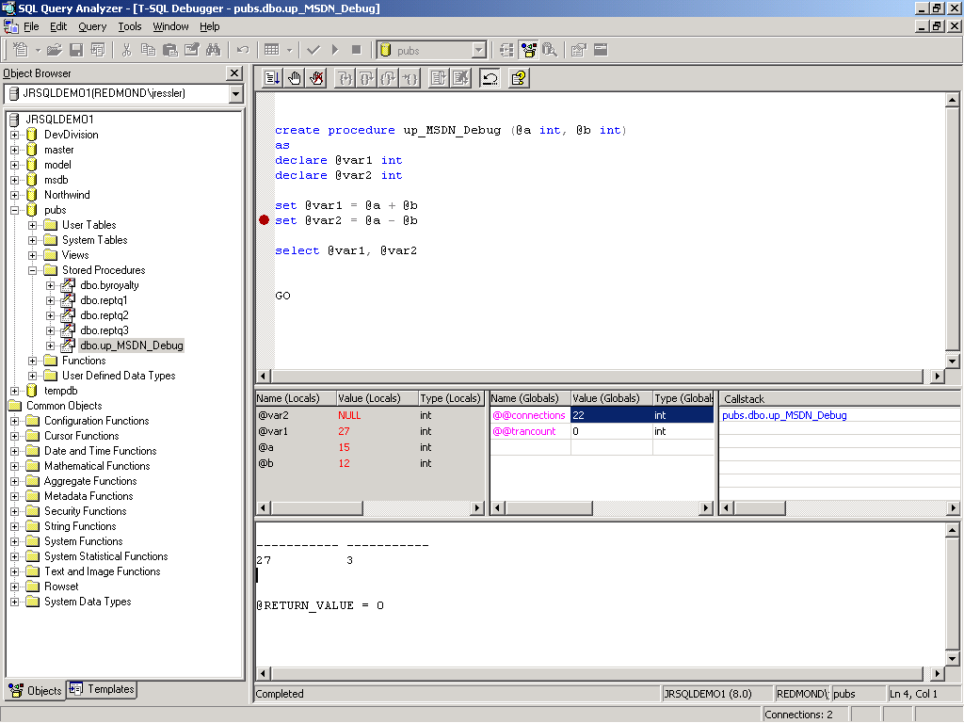
SQL Query Analyzer now includes an object browser and debugger to improve developer productivity.

Figure 1: The Data Mining Model Editor displays the results of data mining analyses (here using the Microsoft Decision Trees Algorithm).
- Maximize availability through fully integrated log shipping and enhanced failover clustering. Log shipping automatically synchronizes physically separated databases by sending transaction logs from one server to another. SQL Server 2000 and its tools are now fully cluster-aware to simplify management. Failover and failback can occur between any nodes in clusters of up to four nodes.
- Take full advantage of your hardware resources by running multiple, isolated applications on a single machine using SQL Server 2000 multi-instance support.

Build applications rapidly, and make sure they stay up and running.
- Centralize, automate, and reduce the costs of management using the Windows® 2000 Active DirectoryTM service and SQL Server 2000 dynamic self-management and tuning. Copy and move databases among servers or instances with no downtime using new Copy Database Wizard.
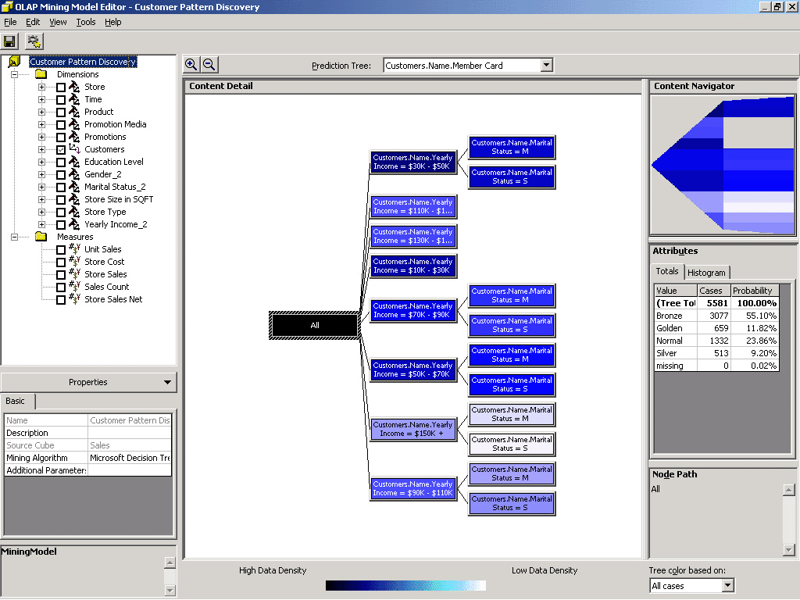
- Deliver robust, scalable database applications rapidly using the improved SQL Server 2000 develop-
ment tools. SQL Query Analyzer now includes a stored procedure debugger. Data Transformation Services expand the ability to move and transform data from any source.
- Improve productivity with T-SQL enhancements. New user-defined functions allow code reuse and simplify development. Maintain consistent data with cascading referential integrity to control the propagation of delete and update operations.
- Take advantage of complete, end-to-end analysis capabilities⎯including data mining⎯with the integrated
SQL Server 2000 extensible Analysis Services. New dimension types support data sets with a wide variety of hierarchies. Flexible security features protect data at the cube, member, or cell level.

Product Highlights

E-commerce
Today’s e-commerce applications require support for XML, secure access to data stores using the Web, and the ability to scale-out with your growing business.
Rich XML Support | Simplify the integration of your back-end systems and data transfer across firewalls using XML.
Web access to data | Connect to your SQL Server 2000 databases and OLAP cubes flexibly by using the Web with no additional programming.
Distributed Partitioned Views | Partition your workload among multiple servers for additional scalability
Maximize uptime | With online backups, fully integrated log shipping and enhanced failover clustering you can maximize database availability.
Web Hosting | You can have your e-commerce solution hosted by a third party with SQL Server 2000 support for multiple instances.
Security | SQL Server 2000 offers you the highest level of security available in the industry. C2 Certification-the highest government security classification.
Simplified Database Administration | Auto-tuning and auto-maintenance features enable administrators to focus on other critical tasks.
Clickstream Analysis | Gain a deep understanding of customer behavior online so that you can make better business decisions.
Improve developer productivity | User defined functions, cascading referential integrity, and the integrated T-SQL debugger enable code reuse to simplify development.
Integration w/ .net Enterprise Servers | SQL Server 2000 in conjunction with other Microsoft Server products such as BizTalk Server and Commerce Server provides even more power for your e-business.
VI SAN | Improve overall system performance with built-in support for a system area network (SAN).
Full Text Search | Use and manage both your structured and unstructured data, including searching through Microsoft Office documents.
Data Warehousing
Microsoft provides the next generation in data warehousing with SQL Server 2000, including enhanced analysis capabilities and improved performance and scalability.
Comprehensive Analysis Services | Solve all your business analysis needs with integrated OLAP and Data Mining capabilities.
Data Transformation Services | Automate routines that extract, transform, and load data from heterogeneous sources.
Data Mining | Discover patterns and trends with data mining, and make predictions about future trends in your business.
Online Analytical Processing (OLAP) | Perform rapid, sophisticated analysis on large and complex data sets using multi-dimensional storage.
OLAP Flexibility | Use multiple dimension types for flexible business analysis.
Closed Loop Analysis | Take analysis one step further with OLAP actions, allowing results to drive next steps in the business process.
Indexed Views | Gain performance from your existing hardware by storing query results and reducing response times.
Meta Data Services | Increase developer productivity and reduce administrative overhead by sharing meta data among different tools and environments using standard information models.
Office 2000 integration | Use Pivot Table Services in Microsoft Excel to enhance your data analysis (See the auto demo on this functionality at).
Data Warehousing Alliance | Choose among broad offerings from third party analysis tools vendors that extend Analysis Services functionality.
Web-enabled Analysis | Analyze data from remote OLAP cubes that are web accessible.
English Query | Enable your users to pose questions in English instead of using Multi-Dimensional expressions (MDX).
Line of Business
Enterprises choose SQL Server for mission-critical line-of-business applications because of its reliability,
ease of administration, and its ability to scale up with their selected hardware configurations.
Simplified Administration | Auto-tuning and auto-maintenance features enable administrators to focus on other critical tasks.
Reliability | Maximize the availability of your business applications with log shipping, online backups and failover clusters.
Scalability | Scale your applications up to 32 CPUs and 64 GB RAM. SQL Server 2000 has demonstrated world record-breaking performance you can leverage. www.microsoft.com/sql/worldrecord
VI SAN | Transfer data directly from SQL Server 2000 to devices on a SAN to achieve higher performance by increasing server interconnect throughput.
Security | Ensure your applications are secure in any networked environment with role based security and file and network encryption.
XML | XML support allows your data to be easily stored for use by web applications.
Application Hosting | Fully exploit your hardware investments – run multiple applications on a single server with SQL Server 2000 multi-instance support.
Extend your application | Support for access by devices such as Windows CE handheld units provides access to applications more broadly and extends your user base.
Web Access to Data | Securely share your database and OLAP cubes with your business partners over the web.
Comprehensive Analysis Services | Use OLAP Services and Data Mining with your business information to perform analysis, reveal patterns and trends. Data mining allows patterns and trends to be revealed, as well as predictions about future directions.
Replication | With SQL Server 2000 you can implement merge, transactional, and snapshot replication with heterogeneous systems.

The Microsoft .NET Enterprise Servers are the comprehensive family of server applications for quickly building, deploying, and managing scalable, integrated, Web-based solutions and services. Designed with mission-critical performance and integration in mind, the .NET Enterprise Servers are built from the ground up for interoperability using open Web standards such as XML. The .NET Enterprise Servers, along with Windows 2000, supply the foundation for the .NET Platform, enabling the third generation of the Internet: where software is delivered as a service, is accessible by any device, any time, any place, and is fully programmable and customizable. The .NET Platform is explicitly designed to enable the rapid development, integration, and orchestration of any group of Web services and applications into a single comprehensive solution.

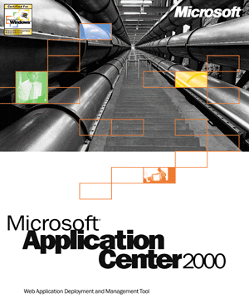
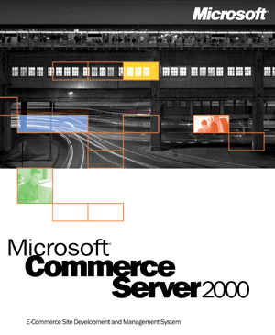
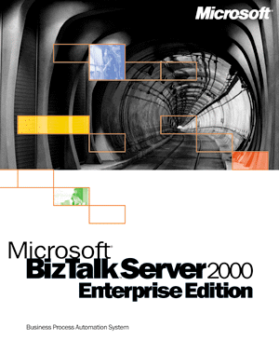

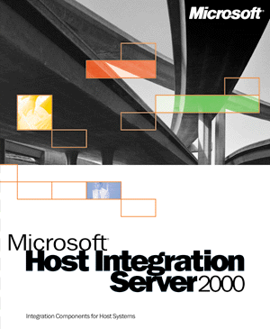
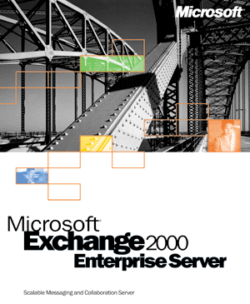



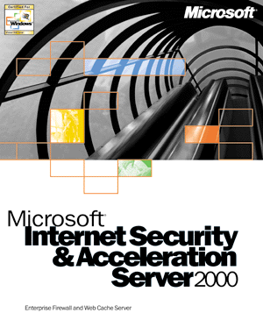

Specifications

To use Microsoft SQL Server 2000 Enterprise Edition,
you need:
- PC with an Intel or compatible Pentium
166 MHz or higher processor
- Microsoft Windows NT Server 4.0 with Service Pack 5 or later, Windows NT Server 4.0 Enterprise Edition with Service Pack 5 or later, Windows 2000 Server, Windows 2000 Advanced Server, or Windows 2000 Datacenter Server operating system
- Minimum of 64 MB of RAM (128 MB or more recommended)**
- Hard-disk space required:***
- 95–270 MB for database server; approxi-
mately 250 MB for typical installation
- 50 MB minimum for Analysis Services;
130 MB for typical installation
- 80 MB for Microsoft English Query (supported on Windows 2000 operating system but not logo certified)
- Microsoft Internet Explorer 5.0 or later
- CD-ROM drive
- VGA or higher resolution monitor
- Microsoft Mouse or compatible pointing device

To use Microsoft SQL Server 2000 Personal Edition,
you need:
(Identical to Enterprise Edition requirements with the following exceptions)
- Additionally supports Microsoft Windows 98, Windows Millennium Edition, Windows NT Workstation 4.0 with Service Pack 5 or later, or Windows 2000 Professional
- Minimum of 32 MB of RAM (64 MB or more recommended)**
Note: SQL Server 2000 Personal Edition is included for desktop and mobile use. Personal Edition does not contain full Enterprise Edition functionality. See www.microsoft.com/sql for more details.

To use Microsoft SQL Server 2000 Desktop Engine,
you need:
(Identical to Enterprise Edition requirements with the following exceptions)
- Additionally supports Microsoft Windows 98, Windows Me, Windows NT Workstation 4.0 with Service Pack 5 or later, or Windows 2000 Professional
- Minimum of 32 MB of RAM**
- 44 MB of available hard-disk space***
Networking support: Windows 95, Windows 98, Windows Me, Windows NT 4.0, or Windows 2000 built-in network software (additional network software is not required unless you are using Banyan VINES or AppleTalk ADSP; Novell NetWare IPX/SPX client support is provided by
the NWLink protocol of Windows networking)
Clients supported: Windows 95,† Windows 98, Windows Me, Windows NT Workstation 4.0, Windows 2000 Professional, UNIX,†† Apple Macintosh,†† and OS/2††

**Additional memory may be required, depending on operating system requirements.
***Actual requirements will vary based on your system configuration and the applications and features you choose to install.
†Supported for client connectivity only; does not include graphical tools support.
††Requires ODBC client software from a third-party vendor.



Professional Association for SQL Server (PASS) is an independent user group community dedicated to supporting SQL Server professionals worldwide.
www.sqlpass.org

© 2000 Microsoft Corporation. All rights reserved. This data sheet is for informational purposes only. MICROSOFT MAKES NO WARRANTIES, EXPRESS OR IMPLIED, IN THIS SUMMARY. The names of companies, products, people, characters, and/or data mentioned herein are fictitious and are in no way intended to represent any real individual, company, product, or event, unless otherwise noted.
Microsoft, Active Directory, BizTalk, the .NET logo, Windows, the Windows logo, and Windows NT are either registered trademarks or trademarks of Microsoft Corporation in the United States and/or other countries.
Other product and company names mentioned herein may be the trademarks of their respective owners.
Microsoft Corporation • One Microsoft Way • Redmond, WA 98052-6399 • USA
Microsoft Canada Inc. • 320 Matheson Blvd. West • Mississauga, ON L5R 3R1 • Canada
0700 Part No. 098-89442 (color)
Part No. 098-89443 (black and white)

